

**Collaboard Wiki pages**

USER Manual

|  |  |
| --- | --- |
| Title: | Collaboard Wiki pages |
| Abstract: |  |
| Status* | Approved |
| Document Owner: | IBV |
| Document Author: |  |
| *Draft, In progress, Reviewed, Authorized, Approved, Completed | |

|  |  |  |
| --- | --- | --- |
| **Document Control** | | |
| Document Distribution: | Internal: | All dev Teams |
|  | External: |  |
| Document Authorization: | Authorizer(s): | GP Santopaolo |

|  |  |  |  |
| --- | --- | --- | --- |
| **Change History** | | | |
| Date | Ver | Changed By | Details |
| 30/09/2021 | 1.0 | Noel Hermans | Initial draft |
|  |  |  |  |
|  |  |  |  |
|  |  |  |  |
|  |  |  |  |

Index

Introduction 3

Purpose of the document 3

Prerequisites 3

Accessing the Collaboard Wiki Pages 3

First time login to the Collaboard Wiki Pages 3

How to navigate through the Collaboard Wiki Pages 5

How to access the Collaboard templates repository 6

# Introduction

## Purpose of the document

This documents how to use the Collaboard wiki pages and template repository.

## Prerequisites

* A valid Azure user account defined in AAD. In case you do not have an account please request it to IBV. They will create an account for you.

## Accessing the Collaboard Wiki Pages

<https://wiki.collaboard.app>

## First time login to the Collaboard Wiki Pages

In case this is your first time to login to the Collaboard Wiki pages, you must have a valid account that can be requested to IBV. After you have received a valid account, you must register yourself in this portal using the following steps:

| **Step** | **Description** | **Commands** |
| --- | --- | --- |
|  | Open a web browers and connect to the URL | <https://wiki.collaboard.app> |
|  | Click on the blue pyramid “Sign in With” |  |
|  | You will be requested to enter your Azure credentials |  |
|  | After successful login , you will be asked to register your account. |  |
|  | Enter your username and Email address. | **Important Notes :**  - the username is the Wiki username and is not related to your Azure account and an email address is not valid.  - the Email address must match the Azure Active Directory (AAD) email address in order to link it correctly with AAD. |
|  | Click Complete Account button to finish the registration. |  |
|  | You account is now linked with AAD and you need to click always the blue pyramid “Sign in With” |  |

## How to navigate through the Collaboard Wiki Pages

1. Make sure you are in the Explore Tab
2. Make sure you click on Repositories

When you click on the Collaboard / Documentation link, you will see the following folder structure :

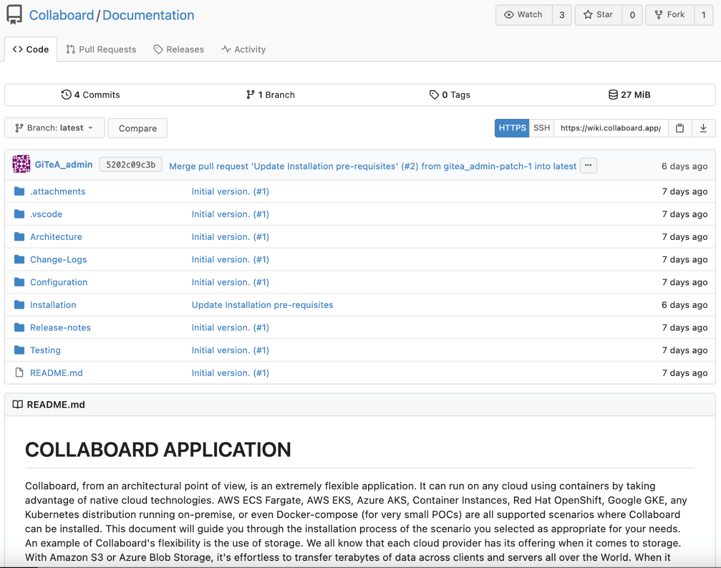

Each folder has each own README to explain about the contents of that specific folder.

For example everything related to the installation of Collaboard has been grouped into the Installation folder. The main README.md page will explain Installation prerequisites.

In case you are lost in the navigation, you can always this on the top link “Collaboar/Documentation” which brings you back to the main page.

## How to access the Collaboard templates repository

The templates repository contains all the scripts, templates, configuration settings that will help you for the installation of Collaboard. For this you can navigate by clicking on the top Link “Collaboard”

As shown in the “How to navigate through the Collaboard Wiki Pages”.

If you want to clone this repository to your local server, you can use the “**git clone**” command.

Example : **git clone ssh://git@wiki.collaboard.app:222/Collaboard/Templates.git**

Or you can click in the Templates repository on the clone button :

You can either use HTTPS with user/password authentication or SSH with private/public key authentication. This requires to upload your personal public key as follow :

1. Click on your account
2. Select Settings from your account menu
3. Select the SSH/GPG Keys TAB on the top
4. Click on the Add Key button to add your public key. **Important : DO NOT UPLOAD your private key here.**